District Athletics News June 29th 2026
Ickford School has taken part in the Aylesbury Vale Athletics for many, many years and we have won the event on at least 7 occasions.
This year, however, there was a huge change …The organisers spoke to me prior to the event, explaining that, as Ickford had won the Small Schools competition for the past seven years, it was time for another school to "have a chance". To achieve this, he had moved us into the Large Schools competition, which consists mainly of three-form-entry Aylesbury schools with around 400 pupils. What concerned me most was the new rule limiting each child to a maximum of three events. However, the children excelled. We had several first-place finishes (Anabel Stevens, Robyn Barnes, Wilf Evans and Vika Hardy) and second-place finishes (Bryony Ellis, Finlay Bennett, Xavi Flood, Robyn Barnes and Vika Hardy), all of which contributed to us finishing second overall, missing first place by just one point! Seeing our Ickford children lifting the trophy rendered me speechless.
Huge congratulations to the team: Oliver Evemy, Zeynep Konak, Fred Ellis, Vika Hardy, Jude Barnes, Anabel Stevens, Wilf Evans, Bryony Ellis, Finlay Bennett, Charlie Morris, Robyn Barnes, Teddy Barber, Ronin Reeve, Elsie Thomas, Elizabeth Smith, Xavi Flood, William Barber, Stella Anzarouth and Matilda Ousley. We are all so proud of you.
As the organiser said to me at the end of the event: "There you go, nothing can stop Ickford... even against the big boys."
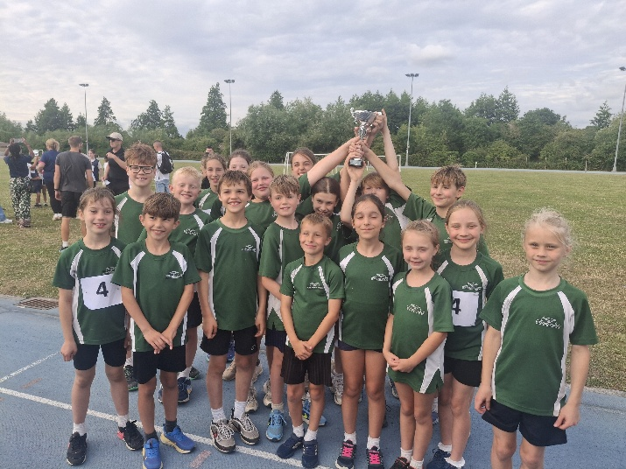
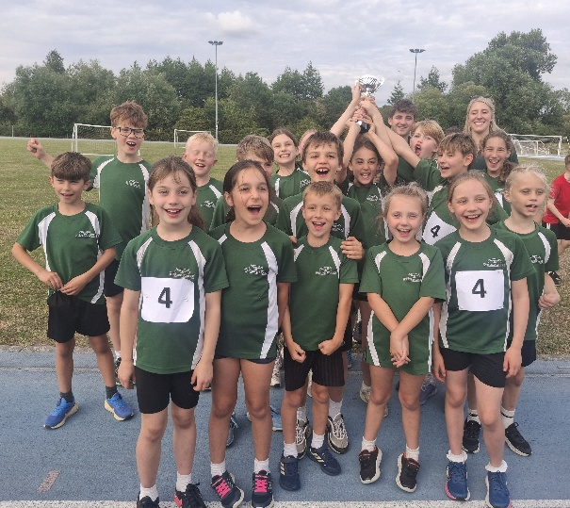
True.

