Drawing Club
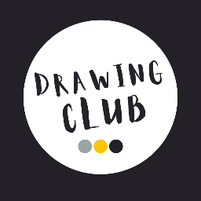
At Ickford School, we use Drawing Club - an imaginative and creative approach to early writing designed by Greg Bottrill. It is used in Reception and Key Stage 1 to inspire children’s storytelling, language and writing through creativity and play.

What is Drawing Club?
Drawing Club immerses children in a world of stories, where imagination takes centre stage. Using a rich mix of picture books, traditional tales and animations, each session begins with a shared storytelling experience before children explore and develop their own ideas. There is no rigid scheme or set texts. Instead, teachers bring stories to life and guide children on exciting creative journeys, placing imagination, language and connection at the heart of learning.

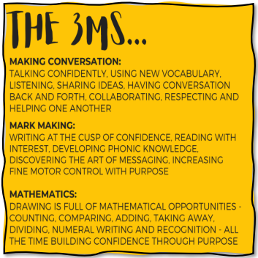
What happens in a Drawing C lub session?
Each week, children explore a new story or animation. They:
- Learn and use exciting new vocabulary
- Draw characters, settings or events
- Add imaginative details such as magic powers, secret passwords or hidden symbols
- Talk about their ideas and share them with others
As children progress, their drawings develop into writing:
- In Reception, this begins with mark-making, moving on to using initial sounds, simple words, then phrases and simple sentences.
- In Year 1, children write simple sentences, applying phonics knowledge, basic punctuation (capital letters and full stops), and simple conjunctions such as and.
- In Year 2, writing becomes more detailed and structured, with expanded sentences, a wider range of vocabulary (including adjectives), and more secure use of punctuation.

Developing a love of writing
Drawing Club supports children to:
- Build a rich and adventurous vocabulary
- Develop confidence in speaking and sharing ideas
- Strengthen fine motor skills needed for writing
- Use their imagination creatively
- See themselves as storytellers and writers

Why Drawing Club?
Drawing Club is designed to make learning meaningful, engaging and joyful. It brings together a wide range of skills across the curriculum, including:
- Storytelling and oracy
- Drawing and mark-making
- Early writing skills
- Vocabulary development
- Mathematics through symbols and patterns
- Collaboration and creativity
Most importantly, it helps children discover A world where anything can happen.
One of the most powerful aspects of Drawing Club is its focus on imagination. Children are encouraged to think in a “What if…?” way—exploring possibilities, sharing ideas and creating their own stories. The more they imagine, talk and create, the more confident and capable they become as young storytellers.

