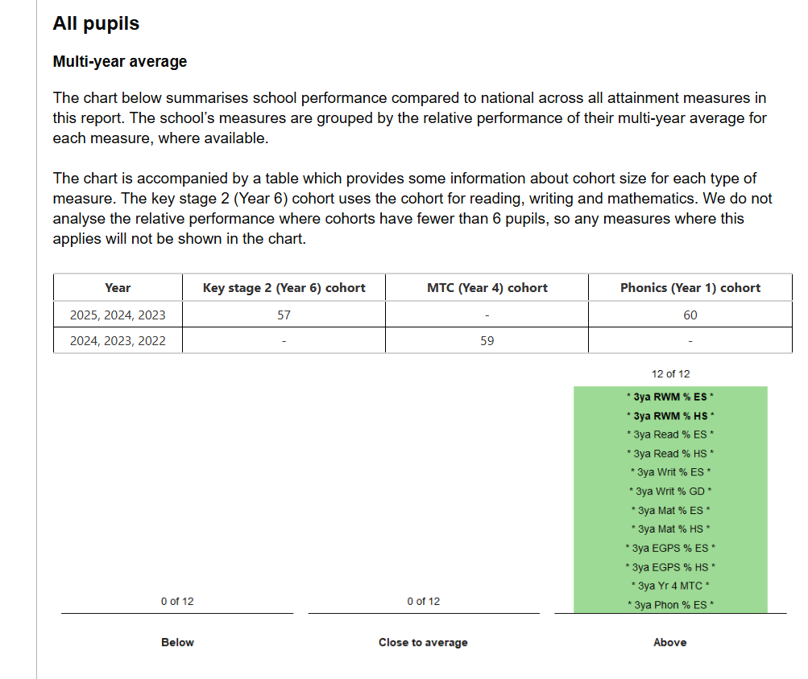
Three-year trend for Key Stage 2 SATs, MTC Year 4 and Year 1 Phonics – data taken from IDSR 2025

