1



Ickford Learning Trust

Scheme of Delegation

Approval: | Trust Board
Date approved:
Review date: | September 2026
Review timescale: | Annual
Keywords: | Governance Delegation, trustee,  member

Contents
- Structure of the academy trust 3
- Lines of accountability 3
- Roles and responsibilities 3
  - The role of the members 3
  - The role of the trustees 4
  - The role of trust board committees 4
  - The role of the Headteacher 4
- Scheme of Delegation 5
  - Key 5
  - Governance framework 6
  - Reporting 7
  - Being Strategic 8
  - Holding to account 10
  - Ensuring financial probity 11

Structure of the academy trust
The diagram below shows the current structure of the academy trust.

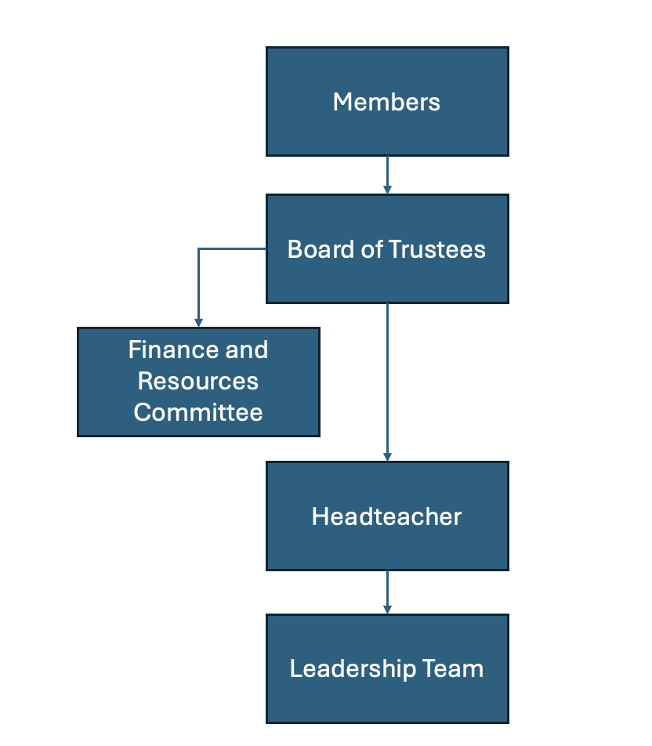

In addition to the above, there are task and finish groups for performance, pay, suspensions and exclusions, complaints and HR issues.

Lines of accountability
The academy trust board of trustees delegates responsibility for the day to day running of the academy to the principal. The trustee board will hold the principal to account for the performance of the academy. The principal in turn holds other members of the leadership team to account by line managing them.
While the board cannot ever delegate its accountability, it can delegate some of the detailed scrutiny, oversight and decision making.
The principal will report to the board on the performance of the academy, although this will be supplemented by the monitoring of trust board committees and individual trustees with any delegated responsibilities.
The principal is performance managed by the trust board through the performance task and finish group.

Roles and responsibilities

The role of the members
The members of the trust have a different status to trustees. Originally, they will have been the signatories to the memorandum of association and will have agreed the trust’s first articles of association (a document which outlines the governance structure and how the trust will operate). The articles of association will also describe how members are recruited and replaced, and how many of the trustees the members can appoint to the trust board.

The members appoint trustees to ensure that the trust’s charitable object is carried out and so must be able to remove trustees if they fail to fulfil this responsibility. Accordingly, the trust board submits an annual report on the performance of the trust to the members. Members are also responsible for approving any amendments made to the trust’s articles of association.
While members are permitted to be appointed as trustees, in order to retain a degree of separation of powers between the members and the trust board, and in line with DfE expectations, not all members should be trustees. The DfE has amended the model articles to state that members are not permitted to be employees of the academy trust.

The role of the trustees
The academy trust is a charitable company and so trustees are both charity trustees (within the terms of section 177(1) of the Charities Act 2011) and company directors. Because trustees are bound by both charity and company law, the terms ‘trustees’ and ‘directors’ are often used interchangeably. NGA uses the term trustee as it avoids the possible confusion caused when executive leaders are called directors but are neither company directors nor trustees.
The trustees are responsible for the general control and management of the administration of the trust, and in accordance with the provisions set out in the memorandum and articles of association and its funding agreement, it is legally responsible and accountable for all statutory functions, for the performance of the trust, and must approve a written scheme of delegation of financial powers that maintains robust internal control arrangements. In trusts, the purpose of governance is to provide:
    - strategic leadership
    - accountability and assurance
    - strategic engagement.
The board of trustees has the right to review and adapt its governance structure at any time which includes removing delegation.

The role of trust board committees
The trustees may establish committees to carry out some of its governance functions which may include making decisions, although any decisions made will be deemed decisions of the trust board. The membership (there must be at least three trustees) and responsibilities of board committees are set out in the committee’s terms of reference. It is usual for the trust board to appoint board committee chairs and committee members according to their skills.
The Academy Trust Handbook makes it clear that the board of trustees ‘should have a finance committee to which the board delegates financial scrutiny and oversight’. In trusts with income above a certain level, there must also be a separate audit and risk committee.

The role of the Headteacher
The Headteacher has the delegated responsibility for the operation of the trust.

The Headteacher is the accounting officer so has overall responsibility for the operation of the academy trust’s financial responsibilities and must ensure that the organisation is run with financial effectiveness and stability, avoiding waste and securing value for money.
The Headteacher leads the leadership team (SLT) of the academy trust and will delegate management functions to the SLT and is accountable to the trust board for the performance of the leadership team.

Scheme of Delegation

Key

Blue box | Function cannot be conducted at this level.
✓ | Action to be undertaken at this level
A | Provide advice and support to those accountable for decision making
<> | Direction of advice and support

4.2 Governance framework
 | Members | Trust Board | Committee | Headteacher
Members: Appoint/Remove | ✓
Trustees: Appoint/Remove | ✓ | ✓
Role descriptions for members | ✓
Role descriptions for trustees/chair/specific roles/committee members: agree |  | ✓ | <A
Parent trustees: elected |  | ✓
Committee chairs: appoint and remove |  | ✓ | <A
Governance professional: appoint and remove |  | ✓
Articles of association: agree and review | ✓ | <A | <A
Adhere to the articles of association | ✓ | ✓ | ✓ | ✓
Governance structure (committees) for the trust: establish and review annually |  | ✓ | <A
Terms of reference for trust committees (including audit if required, and scheme of delegation): agree annually |  | ✓ | <A
Skills audit: complete and recruit to fill gaps |  | ✓
Annual self-review of trust board and committee performance: complete annually |  | ✓
Chair’s performance: carry out 360 reviews periodically |  | ✓
Trustee contribution: review annually |  | ✓
Succession: plan |  | ✓ | <A
Annual schedule of business for trust board: agree |  | ✓ | <A | <A
Set expectations for trustee conduct |  | ✓

4.3 Reporting
 | Members | Trust Board | Committee | Principal
Trust governance details on trust website: ensure |  | ✓ | <A | <A
Register of all interests, business, pecuniary, loyalty for members/trustees: establish and publish |  | ✓ | <A
Annual report on performance of the trust: submit to members and publish |  | ✓ | <A
Annual report and accounts including accounting policies, signed statement on regularity, propriety and  compliance, incorporating governance statement demonstrating value for money: submit |  | ✓ | <A
To determine whether to publish a home school agreement (not statutory) |  |  |  | ✓
Overall responsibility for ensuring that statutory requirements for information published on the school website, including required details of governance arrangements, performance, financial and equality data are met |  | ✓ | <A | <A
To publish and update at least annually a SEN information report (meeting requirements set out in the Special Educational Needs and Disability Regulations 2014) |  | ✓ | ✓ | ✓
Ensure transparency of information |  | ✓

4.4 Being Strategic
 | Members | Trust Board | Committee | Principal
Set the trust’s vision |  | ✓
Set the trust culture and values |  | ✓
Set the trust’s strategy |  | ✓ |  | <A
Champion the trust strategy |  |  |  | ✓
Review progress against the strategy |  | ✓ | ✓
Determine trust policies which reflect the trust's ethos and values including admissions, expenses, SEN, safeguarding and child protection, looked after children, safer recruitment, supporting students with medical  conditions, mental health and wellbeing and curriculum, approve |  | ✓ | <A | <A
Determine trust staffing policies which reflect the trust's ethos and values including appraisal, capability, discipline, conduct and grievance: approve |  | ✓ | <A | <A
Determine trust policy for complaints, health and safety, accessibility plan, premises management, data protection, cybersecurity, FOI, whistleblowing, and code of conduct: approve |  | ✓ | ✓ | <A
Establish trust policy for sex education, careers guidance |  |  |  | ✓
Determine a behaviour and discipline policy that promotes good behaviour among pupils and defines the sanctions to be adopted where pupils misbehave |  | ✓ | <A | <A
To draft content of school behaviour policy and publicise it to staff, pupils and parents. |  |  |  | ✓
To annually determine admission arrangements and to carry out consultation where changes are proposed, or where the governing board has not consulted on their arrangements in the last seven years. |  | ✓ | <A
Ensure a broad and balanced curriculum is in place |  | ✓ | <A | <A
To set the times of school sessions and the dates of school terms and holidays |  | ✓
Agree enrichment/extra-curricular offer including any additional services required |  | ✓ | ✓ | <A

Embed agreed curriculum and enrichment offer within the day-to-day operation of the academy trust |  |  |  | ✓
To establish and agree a Pay policy |  | ✓ | ✓
Management of risk: establish register, review and monitor |  | ✓ | <A | <A
Engagement with stakeholders | ✓ | ✓ | ✓ | ✓
Trust's vision and strategy, agreeing key priorities and key performance indicators (KPIs) against which progress towards achieving the vision can be measured: determine |  | ✓ | <A | <A
Headteacher: Appoint and dismiss |  | ✓
To decide whether to join or form a multi-academy trust |  | ✓
Budget plan to support delivery of trust key priorities: agree |  | ✓ | <A
School staffing structure: agree |  | ✓ | <A | <A
Appoint teaching staff |  | A> |  | ✓
Appoint non-teaching staff |  |  |  | ✓

4.5 Holding to account
 | Members | Trust Board | Committee | Principal
Auditing and reporting arrangements for matters of compliance (e.g. safeguarding, H&S, employment): agree |  | ✓ | <A | <A
To produce and maintain a central record of recruitment and vetting checks |  |  |  | ✓
To have due regard to the need to prevent people from being drawn into terrorism and to oversee the incorporation of the necessary procedures and practices outlined in the Prevent duty into the child protection policy |  | ✓ | <A | <A
Reporting arrangements for progress on key priorities: agree |  | ✓ | ✓ | <A
Performance management of the headteacher: undertake |  |  | ✓
Performance management of staff: undertake |  |  |  | ✓
Establish and review procedures for addressing staff discipline, conduct and grievance |  | ✓ | ✓
Trustee monitoring: agree arrangements |  | ✓ | <A
To review all permanent exclusions and suspensions where the pupil is either excluded for more than 15 days in a term or would lose the opportunity to sit a public examination |  |  | ✓
To ensure that health and safety regulations are followed |  |  |  | ✓
Ensure that school lunch nutritional standards are met |  |  |  | ✓
Maintain a register of pupil attendance |  |  |  | ✓
To ensure provision of free meals to those pupils meeting the criteria, including Universal Infant Free School Meals (if applicable) |  |  |  | ✓
Deliver careers guidance, with regards to statutory requirements |  |  |  | ✓

4.6 Ensuring financial probity
 | Members | Trust Board | Committee | Principal
Chief financial officer for delivery of trust’s detailed accounting processes: appoint |  | ✓ | <A
Trust's scheme of financial delegation: establish and review |  | ✓ | <A | <A
Appoint external auditor | ✓ | <A | <A
External auditors' report: receive and respond |  | ✓ | <A | <A
Headteachers pay award: agree |  | ✓
Staff appraisal procedure and pay progression: monitor and agree |  |  | ✓ | <A
Benchmarking and academy trust value for money: ensure robustness |  | ✓ | <A
Develop trust procurement strategies and efficiency savings programme |  |  | ✓
Develop the trust budget |  |  |  | ✓
Deliver monthly management accounts and forecasts |  |  |  | ✓
To approve the first formal budget plan, three year budget and budget forecast return each financial year |  | ✓ | <A
To agree annual action plans and monitor how school premiums are spent (i.e. PE and sports premium, service premium and the pupil premium) |  | ✓ | ✓
To establish and agree charging and remissions policy |  | ✓ | ✓
Ensure adequate insurance cover is in place |  | ✓
Maintain the risk register |  | ✓
Manage conflicts of interest and related party transactions |  | ✓

